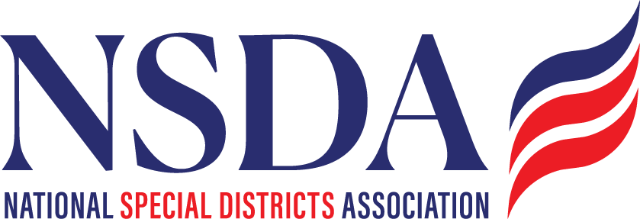
NSDA Federal Advocacy Committee Summary
5.28.26

Note: This summary only includes key highlights, please see slide deck for more detailed information.

Welcome and Updates: Ann Terry
Ann Called to order and turned it to Manatt to review their slide deck.

Federal Advocacy Update: Manatt Phelps and Phillips, LLC & Chantal Unfug
- Special Districts Fly-in Recap:
  - Review of Success, overview from Manatt about their activities on the bill
  - CBO Score was released – critical milestone. Chantal shared it with Texas so they can thank Fallon again.
  - Additional Cosponsors:
    - Request key member states reach out again to their delegation to secure co-sponsorship. Manatt will work with each priority team
  - Outreach to county organizations in member states
    - Request for each member state to reach out to their County Association to share a bill update and request their support up to NACO. Ask for them to fill out the Support Form https://www.nationalspecialdistricts.org/support-our-efforts-to-pass-h-r-2766-s-2014

- Surface Transportation Reauthorization
  - Reviewed win’s and status – 22% of funding will be earmarked for local governments
  - 25% of Bridge funding will be set aside for locally owned bridges
- FEMA Review Council report
- New PFAS rules
  - Provided overview of roll-backs on limits, allowing 2 additional years and rescinding some limits.
  - Public Comments and Public meeting July 7 are in process
  - Manatt will reach out to national partners to engage NSDA. Glen (CASD) serves on the ACUA advocacy committee and will reach out to his leadership
- Appropriations status update
  - 7 of 12 marks up are done.
  - Senate starting week of June 1
- Fire Smart Act
  - Padilla will be introducing potentially week of June 1
  - Manatt is working on a quote from NSDA for the press release and comments at Introduction – looking at House companion commitments
- Financial Data and Transparency Act
  - Chantal and David will provide background information to the group
  - Manatt will review and come back to us
- Farm Bill
  - Manatt will send us a summary of the Rural Health and any other key highlights.
- Federal Funding
  - The President is expected to release a statement outlining broad authority in revamping processes for discretionary funding. NSDA will share it as an update.
- Housing Update
  - Passed 21st Century ROAD home Act

Other:
- SBA: Feedback on letter regarding ADA Accessibility rules
  - Chantal sent a draft letter for review and will send it with edits to the SBA
- Planning for 2027:
  - Special District Day 2027
    - Need to prepare and send out information earlier
  - Fly In Summit
    - Next steps – Manatt will brainstorm this, but we will need to work on a scope, audience, and agenda
  - Platform planning will begin August 2026
- Committee feedback: Are there other issues to take positions on or do social media about? NA

