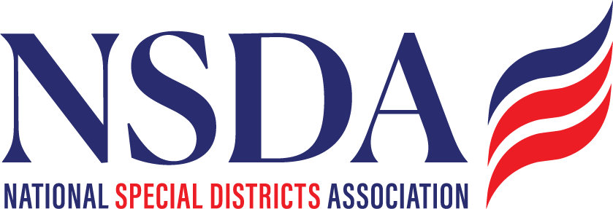

NSDA Federal Advocacy Committee – Meeting Summary
April 24, 2025 | 1:00 PM MT
Welcome and Updates
Ann Terry welcomed attendees and previewed key federal issues impacting special districts.
Federal Advocacy Update, Paragon Government Affairs
General Overview: Monitoring
No Legislative activity to address yet, but Budget Reconciliation will be the priority once Congress comes back to session when they will go thru the mark up process in multiple committees. Focus on 2017 tax cuts and moving the President’s agenda forward. They will consider off-sets, but we do not see much impact to Special Districts on bigger sections such as Medicaid, but are watching closely for any that might pop up – such as cuts to FEMA.
ASAE: Monitoring
This is on the long list of issues to track. Everyone is well aware of the muni bond outlook, but the budget mark up process may consider changes. The work now, such as Rep. Bacon’s letter and other key Republicans in Financial Services, is pre-emptive prior to House Ways/Means work. Still watching impacts to non-profits, hospitals, and private activity bonds in higher ed, advanced funds etc. David will continue sharing what he has from PFN. W/M mark up: May 12, 13th. NSDA is on record with a letter to Ways and Means Committee and Congressional leadership advocating for the preservation of the muni bonds etc. Ann reported the coalition is growing with other states associations in multiple industries.
H.R.2766: Active Priority
Roll out was not communicated to stakeholders, but Rep Fallon is the lead, co-lead Petterson. NSDA updated all web based information on the Bill, and communicating introduction. This will be the key platform for the DC trip. Last year we had a strong support system, and will try to replicate it, with getting as many co-sponsors as possible. No additional report on Senate side beyond getting cosponsors, but will have more after DC trip and will discuss a May-June push on the “no” votes, the Freedom caucus, and critical states prior to a House floor vote. Sen Rand Paul for example is a key target, and meetings take time to set them up. Having a longer runway this time is a positive message to Fallon. Paragon and Chantal will lay out the June local strategy at the next Fed Advocacy meeting May 22, 2025.
PFAS Liability: Active
House bill has been reintroduced. NSDA will resubmit letter for the record, and request for co-sponsors, Senate has not yet filed a companion bill.
Fix our Forests: Active
Looking to Senate to move it forward. 25% voted in favor but had some concerns about litigation. Sen Padilla reached to Curtis, Sheehey, Bennett on a compromise bill with some guardrails etc. Expected mark up in June. NSDA language is in the bill, and is on record with our letter.
Other Business:
Interest about insurance affordability is growing. Senate Banking Committee has scheduled a hearing on the role of the Federal govt in the insurance arena. For example, they may want to discuss BRIC grants in this hearing as well.
DC Fly in:
Paragon ran thru the schedule and reviewed highlights. Packets will be ready, talking points and itinerary will go out prior to the trip. Generally this year we are over communicating to all contacts. Kyle discussed his field team and member strategy, including Cosponsor requests, and the focus on the remaining Republican delegations in California. CA already has 4 of the nine (Rs) which is impressive, and yes, continue to keep calling to encourage co-sponsors. Its critical to get other states beyond California, so it shows broad support. Lastly, Paragon continues to reach out to the White House, but they are not open yet to meeting. They are meeting with Special Districts, but are not clear on where SD’s SPD’s should be “housed”. Office of Public Liaison v WHOIGA.

