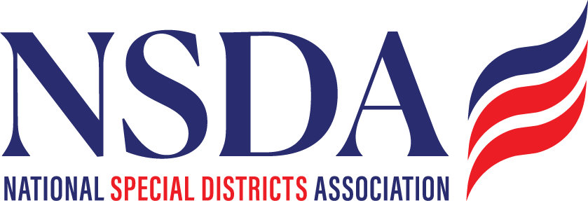

NSDC Federal Advocacy Committee

Meeting Summary

5.22.2025

Welcome and Updates: Frank Stratton

Federal Advocacy Update: Paragon Government Affairs

General Overview - Lawmakers Wrapping up pre-Memorial Day Push

* Recess starting next week with big push for the July 4th week.
* Budget Reconciliation Update
  + "One Big Beautiful Bill Act" (H.R. 1) Proposal will create larger scale fundamental changes, passed the House 215-214.
  + Senate will only need a simple majority to pass it and is expected to make substantial amendments.
  + Key impacts to watch: Safety net programs, cost shifts for SNAP are proposed to require state matches and administrative costs additions. Medicaid – provider taxes which fund rural hospitals does not have a reduction of the taxes, and do not allow increases nor new taxes. So current program would be allowed to continue. Chantal will reach out to Matt Ellsworth to see if there is a district impact analysis done for hospital districts.
  + Secure Rural School is proposed to extended for three years.
  + Muni Bonds – Is not included this time, so is safe at this point. Thank you to David U for his liaison role.
  + ASAE: an option has been preserved at this time. Impact Coalition has minor concerns, but this at this time is a win.
  + Farm Bill: a skinny Farm bill is included. There is no incentive for Congress at this time to try for a larger package. Forestry reforms will be shifted to the FOFA or other forest related bills.
* Special District Fairness and Accessibility Act
  + June strategic push will be sent out to membership ASAP after this meeting**.** This includes targets, speaking points and background reminders. **Call to Action!**
    - **Focus on relationships with other State Associations and Districts.**
    - **Chantal will go back and look at the survey responses to the question of “who do you know”?**
  + House – focused on the reconciliation process so this was not front and center, but June is good timing to get attention.
  + Senators Cornyn and Merkley are holding it for now until they have a HSGAC (r) on board. Paragon continues calling, meetings key Congressmembers. Florida has been pushing for Rick Scott’s support. We need everyone to reach out again to their and new target states. We will look for Pettersen’s Press release.
* Creation of a Congressional Special District Caucus
  + Paragon is doing the ground work and is moving forward with creating the caucus – Congressmembers Fallon and Pettersen are both very interested and moving forward.
  + Function is internal advocacy focussed and can be a liaison starting point within Congress for special district issues.
* FEMA Reform Proposal - Draft Bill in process: Transportation and Infrastructure Committee has it online with a 1 page summary; There will be a **call to action** for feedback and information will be sent out to appropriate members. A few highlights: It is proposed to become a Cabinet Agency, will include proactive mitigation work as an incentive for FEMA support, a universal survivor application, and data sharing (needs to be beefed up)
* Private Equity Roll-ups of Fire Truck Manufacturers
  + Background: Private equity started buying up truck manufacturers and consolidating companies and have increased prices. Costs are now over $1m. Sen Warren, Sen Hawley, Sen Banks sent a letter, Paragon reached out to Sen Warren and are in discussions on how to support her. They also sent this to the Fire fighters and Chiefs, DOJ has been looped in regarding anti trust issues. Chantal will send it out.
* Regulatory Update on EPA
  + EPA recently moved to rescind the PFAS regulations and specifically looking at the 4 families of chemicals, and for the 2 sources proposed delays to 2031.
  + EPA SRF: Proposals to cut funding for compliance by 90% from $2.7B to $300m; Waiting for skinny budget proposal from the President but expected mark ups in June/July. Advocacy on the SRF cuts is important.

Next meeting date: June 26, 2025