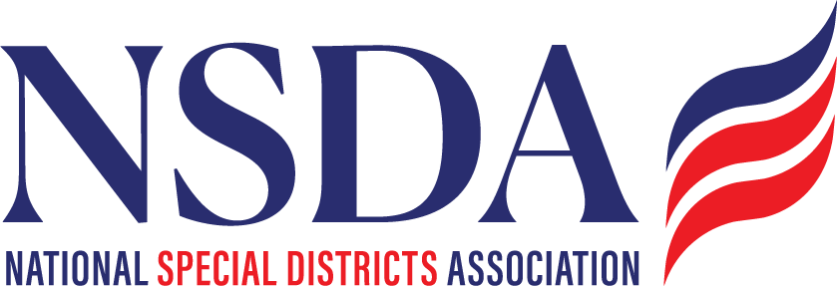
NSDA Federal Advocacy Committee Agenda
6.25.26 1:00 pm MNT time

https://us06web.zoom.us/j/85240694788?pwd=cFaB1TfCFa370f9hHB8T7easZI2uc1.1
Meeting ID: 852 4069 4788 Passcode: 818259
One tap mobile:
+17193594580,,85240694788#,,,,*818259# US
+13462487799,,85240694788#,,,,*818259# US (Houston)

Welcome and Updates: Ann Terry

Federal Advocacy Update: Manatt Phelps and Phillips, LLC & Chantal Unfug
Priority Issues:
- SDFFAA of 2026:
    - Additional Cosponsors (Target – FLA, SC, CO)
    - Outreach to county organizations in member states

  - OMB: Federal Grants Proposal
    - Big 7 extension letter
    - Next steps (July 1 feedback)
    - Farm Bill

Issues to Watch:
- Protect Charities Act
- Fire Apparatus Costs
- FEMA Report Implementation
- Planning for 2027:
  - Confirm Dates
  - Fly In Summit
- Committee feedback: Are there other issues to be aware of?

General Overviews:
- Appropriations status update

