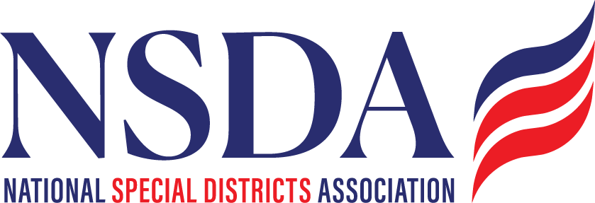

NSDC Federal Advocacy Committee Agenda
1.22.26 1:00 pm MNT time

https://us06web.zoom.us/j/85240694788?pwd=cFaB1TfCFa370f9hHB8T7easZI2uc1.1

Meeting ID: 852 4069 4788 Passcode: 818259
One tap mobile
+17193594580,,85240694788#,,,,*818259# US
+13462487799,,85240694788#,,,,*818259# US (Houston)

Welcome and Updates: Ann Terry
Federal Advocacy Update: Paragon Government Affairs
- Kick off of the 2026 Legislative Session (big picture overview)
- Status of Fiscal Year 2026 Appropriations (Federal Budget Update)
  - minibus funding package passage 28b discretionary funding impacting local govs
- Special District Fairness and Accessibility Act
- Fix Our Forests Act (FOFA) update
- Water Infrastructure for Firefighting proposal
- Sens. Padilla-Sheehy Wildfire Resilience Bill
- Water Resources Development Act (WRDA) reauthorization
- DC Days – Fly in: May 4,5,6,7 (same hotel – Navy Yard) We need to confirm who is going to DC.

Members’ new items questions or discussion (Chantal’s additions)
- surface transportation reauth
- liability exemption for PFAS
- creation of the US wildland Fire Service
- Mustaffa Hessabi – Class action lawsuit update re: fire apparatus.

