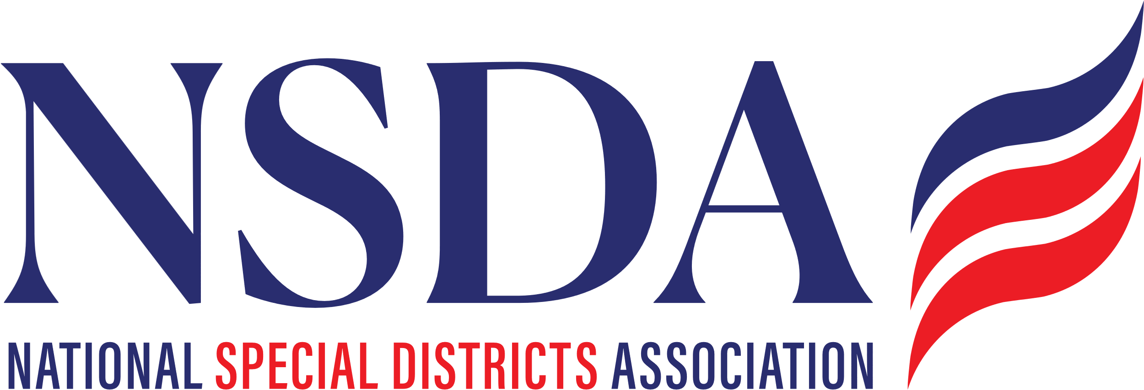

**ACTION ALERT**

**Special District Fairness and Accessibility Act (S.2014)**

*June 11, 2025*

Senator John Cornyn (R-TX) introduced the Special District Fairness and Accessibility Act. The bipartisan bill (S. 2014) is cosponsored by Senators Jeff Merkley (D-OR), Bernie Moreno (R-OH), and Ruben Gallego (D-AZ). The bill will codify a first-ever, formal definition of “special district” and would require the White House Office of Management and Budget (OMB) to issue guidance to federal agencies requiring special districts to be recognized as local governments for the purpose of accessing Federal programs and to create consistence among Federal agencies.

**Requested Action**

* **All Special District stakeholders are encouraged to send a Co-Sponsor request letter to their congression members.**
* **Special districts and partnering stakeholders with a direct connection to Kentucky/Senator Rand Paul are urged to contact Senator Paul’s office to urge him to support S.2014.**
* **The Bill language is identical to H.R.2766 as introduced in the House.**

**Additional Background & Talking Points**

S. 2014 will:

1. Establish a first-ever, formal definition of “special district” in federal law; and,
2. Require OMB to issue guidance to federal agencies requiring special districts to be recognized as local governments for the purpose of federal financial assistance determinations.

* According to the Congressional Budget Office (CBO), enacting H.R.2766 would not affect direct spending or revenues (the bill is cost-neutral).
* Special districts are ineligible for – or have barriers to accessing – federal programs due in part to the fact that the U.S. Census Bureau does not recognize special districts as geographic units of government due to the absence of a formal statutory definition. Moreover, special districts do not qualify for certain discretionary grants due to a lack of consistent program guidance among federal agencies.
* Examples of program ineligibility / barriers to access include:
  + **Transportation Alternatives / Rails-to-Trails**
  + USDOT’s **Reconnecting Communities** **Program**
  + U.S. Department of Agriculture (USDA) **Rural Housing Preservation Grants**
  + U.S. Environmental Protection Agency’s (EPA) **Clean-Heavy Duty Vehicles Program**