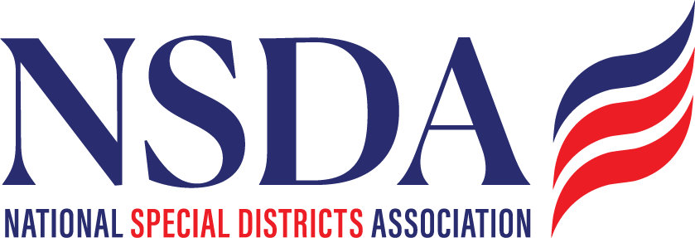

NSDC Federal Advocacy Committee

Agenda

6.26.2025

1:00 pm MNT time

[*https://us06web.zoom.us/j/85240694788?pwd=cFaB1TfCFa370f9hHB8T7easZI2uc1.1*](https://us06web.zoom.us/j/85240694788?pwd=cFaB1TfCFa370f9hHB8T7easZI2uc1.1)

*Meeting ID: 852 4069 4788*

*Passcode: 818259*

*One tap mobile*

*+17193594580,,85240694788#,,,,*818259# US*

*+13462487799,,85240694788#,,,,*818259# US (Houston)*

Welcome and Updates: Ann Terry

Federal Advocacy Update: Paragon Government Affairs

General Overview

* Pre-July 4 Recess Push
  + Budget Reconciliation Update
  + FY 2026 Appropriations Update
* Status report on the *Special District Fairness and Accessibility Act* (H.R. 2766 & S. 2014)
* House action on WIPPES Act (H.R. 2964)
* House committee action on the *Promoting Efficient Review for Modern Infrastructure Today (PERMIT) Act* (H.R. 3898)
* OSHA Heat Rule hearings

Members’ new items questions or discussion

Next meeting date: July 24, 2025