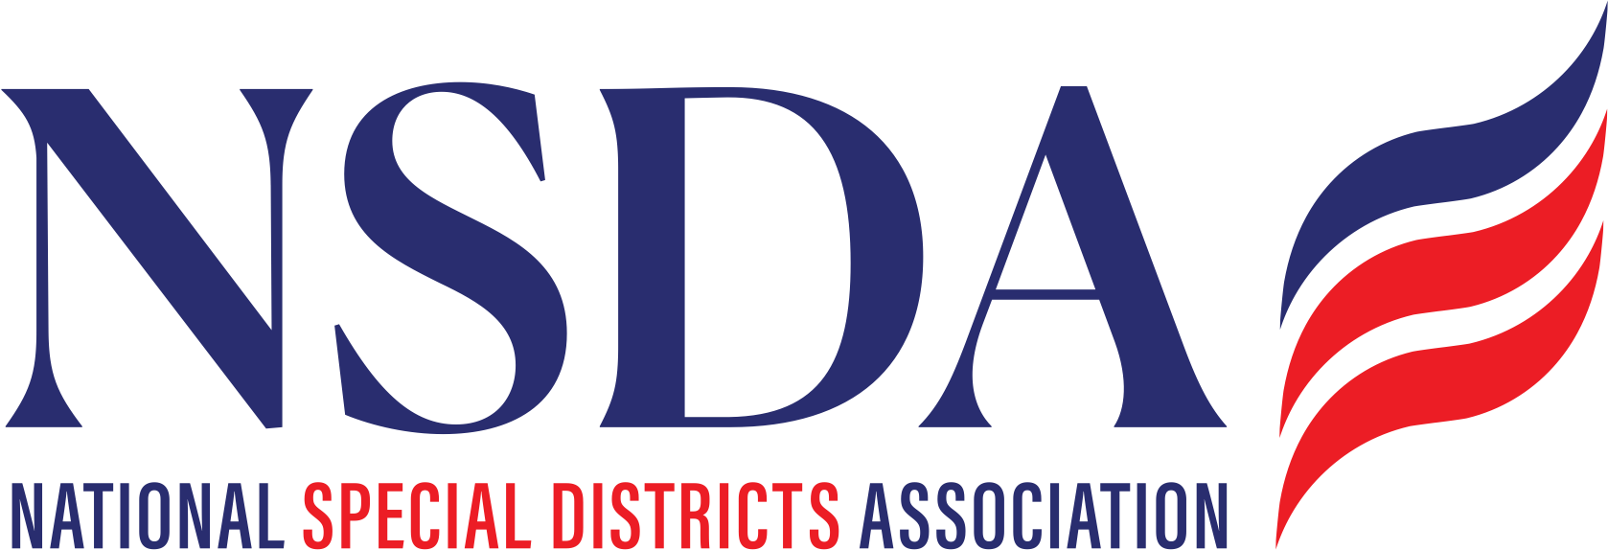 **your logo here**

[Date]

The Honorable __________

U.S. Seante

_______ Senate Building

Washington, D.C. 20515

**RE: COSPONSOR the *Special District Fairness and Accessibility Act S. 2014***

Dear Senator ________:

On behalf of _________, I urge you to cosponsor S. 2014, the *Special District Fairness and Accessibility Act*. This important bipartisan bill would establish a formal definition of “special district” in federal law and require the Office of Management and Budget (OMB) to issue guidance to federal agencies requiring special districts to be recognized as local governments.

[Brief description of your district.]

Special districts are at the heart of the trust equation as local governments created by the people of a community to deliver specialized services essential to their health, safety, economy, and well-being. In Your State, there are over XXX special districts championing local solutions and providing a broad range of essential services and infrastructure.

Despite the significance of special districts throughout the United States, federal law lacks a consistent definition of these special purpose units of local government. As a result, some communities served by special districts face challenges in accessing federal funding opportunities, as their local service providers are commonly omitted from the definition of eligible units of local government in legislative proposals that authorize federal programs and funding. Moreover, special districts lack official population figures and are therefore not recognized by the U.S. Census Bureau as “geographic units of government.” As a result, special districts are unable to gain access to certain resources.

Sponsored by Senator Cornyn (R-TX) and Senator Merkley (D-OR), the *Special District Fairness and Accessibility Act* represents a bipartisan effort designed to ensure that special districts have the same access to federal programs as other units of local government. While often some of the smallest units of governments that interface with your constituents, special districts provide core and important services to the American public every single day. As such, we urge your cosponsor on this important legislation.

Respectfully,

[Name]

[Title]

cc:

Senator John Cornyn

Senator Jeff Merkley

National Special Districts Association

Paragon Government Relations