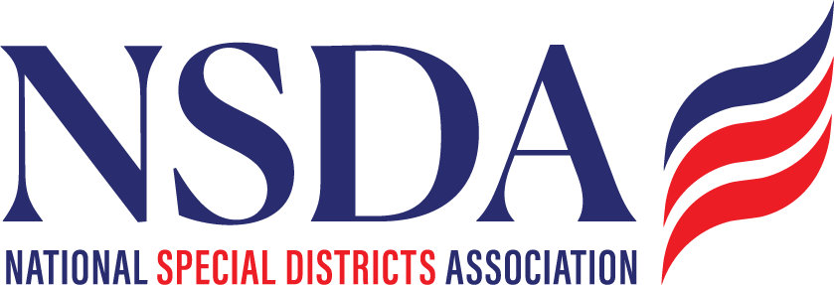

NSDC Federal Advocacy Committee

Summary

6.26.2025

Welcome and Updates: Chantal Unfug  
Introductions: Attendees:

Jennifer

Anthoney

Chantal

Clarke WASWD

Liz

Dean

Jason J

Jeffrey B

Koe, Tom, Hasan

Federal Advocacy Update: Paragon Government Affairs

General Overview

* Pre-July 4 Recess Push: This is the sole focus of Congress and the White House. The procedure allows senate leaders to avoid a filibuster, and have a simple majority. Center piece – tax and jobs act; programmatic spending off sets in the entitlement programs. The cuts to SNAP and Medicaid amount to billions over 10 years. Millions of people will lose coverage, which will probable force states to cover. State/County budgets cost sharing will increase drastically. Parliamentarian has determined on some sections and provisions do not meet the threshold. Free flowing target. President wanted a bill by July 4th. Only 3 republicans can be lost. This is Trump’s signature bill. Debate may commence this weekend with a final vote next week in the house. July 4th is not a requirement, it is for the optics.
  + Budget Reconciliation Update
  + FY 2026 Appropriations Update: “Regular”Budget for discretionary budgeting. Mark ups have started, 12 Agencies’s budgets have begun. Paragon is monitoring Programs for Districts
* Status report on the *Special District Fairness and Accessibility Act* (H.R. 2766 & S. 2014):
  + ON TRACK. Continued communications, outreach
  + Want more members on the bill, both R and D.
  + Next big push will be an August one
  + House is on track to fast track it TBD
  + Chantal will keep calling Kentucky Districts
* House action on WIPPES Act (H.R. 2964)
  + Monitoring. Chantal has social media ready for this once milestones are met in Congress.
* House committee action on the *Promoting Efficient Review for Modern Infrastructure Today (PERMIT) Act* (H.R. 3898)
  + At this time it is a Partisan bill on clean water permitting. Moved thru committee. Expecting a lengthy process, a lot of disagreement on how to create efficiencies. For example, Court case 2022, Forest Service to require Fire service and aerial fire retardant. US FS courts allowed to continue while the permit was going thru their process. By pass ALMAFA bill states Fire service does not need a permit.
* OSHA Heat Rule hearings:
  + Started in the Biden Administration on worker safety rules, Process continues in OSHA, but it is unclear if it will move forward. Already seeing massive layoffs including the entire HEAT team. Hearings happening now thru next week.

Members’ new items questions or discussion:

Fire Truck Investigation. Private equity firms purchasing manufacturers – delays, and increased costs. Congresses asked for an investigation into it Warren, Banks sent letter to fire chiefs requesting impacts. NSDA expressed our concern. The lead staffer left so they are getting up to speed.

Earmarks 2027: 2026 process has already started and deadlines have passed, so District need to be ready for January 2026 for the 2027 year. NSDA can do social media and promotions in August to encourage districts to reach out to their congressional offices to be ready for Jan 2026 launch.

FEMA/BRIC: FY26 appropriations process – in the budget FEMA actually gets an increase at the same time the leadership talking about eliminating it. Some want it to be a cabinet level appointment. TFG’s webinar will be posted online. BRIC: The administration has stopped it for now, pulled money back from any contracts not started. IN play.

Census:

Caucus:

Paragon Webinar: July 8

Next meeting date: July 24, 2025