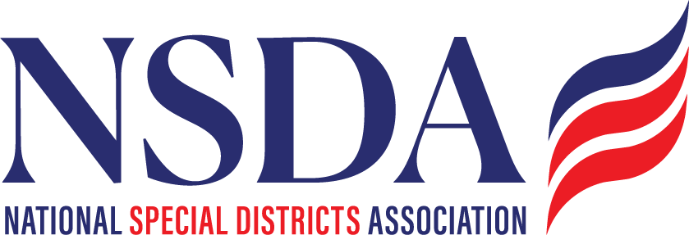

NSDA Federal Advocacy Committee Agenda
7.23.26 1:00 pm MNT time

https://us06web.zoom.us/j/85240694788?pwd=cFaB1TfCFa370f9hHB8T7easZI2uc1.1
Meeting ID: 852 4069 4788 Passcode: 818259
One tap mobile:
+17193594580,,85240694788#,,,,*818259# US
+13462487799,,85240694788#,,,,*818259# US (Houston)

Welcome and Updates: Ann Terry

Federal Advocacy Update: Manatt Phelps and Phillips, LLC & Chantal Unfug

Priority Issues:
- Overview of strategy on the SDFAA: Current landscape and overall congressional dynamics.
  - SC, FLA, CO
- Federal budget update:
  - An early continuing resolution and Reconciliation 3.0
- Water Resources Development Act (WRDA):
  - Inclusion of the Fire SMART Act and water infrastructure reauthorizations.
- Update from NACo’s Annual Conference:
  - New NACo policy in support of special districts revenue.
- The OMB rule:
  - Summary of comments submitted by NSDA and other stakeholders, plus recent news in the legal battle over cancelled federal grants.
- FAA drone flight restriction rule:
  - Extended comment period for UAFR designations covering dams, water/wastewater and other critical infrastructure.
- FEMA reform:
  - T&I hearing on the FEMA Act (H.R. 4669) and prospects for FEMA reform.

  - Census Funding

Committee Discussion

Next Meeting: August 27th

Proposed Resolution Opposing Federal Government Nonpayment of Special District Fees
Issue: The federal government refuses to pay its fair share, arguing it is a tax rather than a fee.
Proposed Policy: The National Association of Counties (NACo) supports federal regulatory and legislative efforts to ensure the federal government pays its fair share of special district fees.
Background: Under law, many states allow counties and other local governments to create special purpose districts to fund specific services such as drainage, drinking water, sewer, road construction, police, fire and other services as defined under state law. Through these special districts, real estate parcels, which are owned by individuals, businesses and other entities, are assessed costs for projects that benefit the landowners within that district. For example, under state law in Iowa, private landowners have the ability to create drainage districts for agricultural, sanitary and flood control purposes. When the drainage district undertakes drainage improvements or repairs all landowners in the district are required to pay their share of the expense incurred during the repair or improvement.
In recent years, the federal government has been purchasing land within these districts and refusing to pay their share when improvements and repairs are completed, arguing that it is a tax and under federal law, the federal government is not required to pay state or local taxes. In Iowa specifically, the U.S. Fish and Wildlife Service is refusing to make their payments. This has repercussions on all other landowners including county and state road departments and railroads within the district as they must pay the federal government’s share. Notwithstanding, the fee is not a tax, nor is it an actual assessment; it is a payment due from all landowners within the district who benefit from the contracted work done within that district. For an Iowa drainage district, this contracted work could encompass ditch maintenance, levee repair, tree removal, engineering and attorney fees.
Fiscal/Urban/Rural Impact: If the federal government or its agencies want to be landowners, they must pay their share rather than shifting this burden onto others within the district to pay the government’s share.
Sponsors(s): Dean Kluss, Supervisor, Wright County, Iowa

