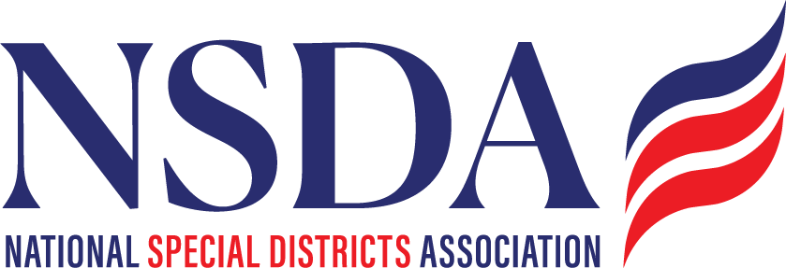

NSDA Federal Advocacy Committee Summary
7.23.26

Welcome and Updates: Ann Terry

Federal Advocacy Update: Manatt Phelps and Phillips, LLC & Chantal Unfug

Priority Issue:
- Mannat provided an overview of strategy on the SDFAA: Current landscape and overall congressional dynamics.
  - Met with Rep Pat Fallon’s staff and Christian Hoerhner, House Oversight Committee and heard for the first time, the real headwinds legislation is facing in this Congress. The Republican’s have shifted into a mode to ensure unification of all votes, so 8 no votes is a barrier. Also due to this and Congressional backlogs, our time is running short.
  - Its critical we pull out all the stops to push our Board members, districts and activate the network. Advice is to be a pest, don’t be shy!
  - Mannat reviewed an FAQ to bust myths
  - The group discussed plan B – trying to attach this to another bill; and or pushing for the definition in multiple bills as they move forward.
  - TO DO:
    - Manatt review and Chantal to update, post online in member resources, and send out: updated letter templates, Alert verbiage etc. and possibly an article, so states can tailor their contacts
    - Manatt will reach out to SC, FLA, CO
    - Everyone should call their house members to continue soliciting co-sponsors. Intell said we needed to triple the number from 30 to 90.
    - Mannat has set up a spreadsheet tracker.
    - Chantal will create the State Profiles for these priority states with DKS.
    - Set up calls with State leads for the No votes from House Committee House Freedom Caucus:
      - AZ: Gosar, Biggs, Crane
        - Mannat and Chantal to start with Mary Dalton – AZ Fire Districts Association
      - TX: Gill
        - Mannat/TSDC to call Gill.
      - PA: Perry
        - Mannat
      - CO: Boebert
        - Manatt/Ann/Megan at SDACo
      - VA: McGuire
        - Manatt
    - Focus on in person meetings during the August recess

Other issues reviewed and in the presentation.

- Federal budget update:
  - An early continuing resolution and Reconciliation 3.0
- Water Resources Development Act (WRDA):
  - Inclusion of the Fire SMART Act and water infrastructure reauthorizations.
- Update from NACo’s Annual Conference:
  - New NACo policy in support of special districts revenue.
- The OMB rule:
  - Summary of comments submitted by NSDA and other stakeholders, plus recent news in the legal battle over cancelled federal grants.
  - Over 300,000 comments – including NSDA’s
- FAA drone flight restriction rule:
  - Extended comment period for UAFR designations covering dams, water/wastewater and other critical infrastructure.
- FEMA reform:
  - T&I hearing on the FEMA Act (H.R. 4669) and prospects for FEMA reform.

  - Other issues? Census Funding

Committee Discussion:
- Save Charities Act – NSDA lead – Kyle Packham
  - Kyle will follow up and confirm with Ann that NSDA will support once we have seen the final language.

Next Meeting: August 27th

NACO:
Proposed Resolution Opposing Federal Government Nonpayment of Special District Fees
Issue: The federal government refuses to pay its fair share, arguing it is a tax rather than a fee.
Proposed Policy: The National Association of Counties (NACo) supports federal regulatory and legislative efforts to ensure the federal government pays its fair share of special district fees.
Background: Under law, many states allow counties and other local governments to create special purpose districts to fund specific services such as drainage, drinking water, sewer, road construction, police, fire and other services as defined under state law. Through these special districts, real estate parcels, which are owned by individuals, businesses and other entities, are assessed costs for projects that benefit the landowners within that district. For example, under state law in Iowa, private landowners have the ability to create drainage districts for agricultural, sanitary and flood control purposes. When the drainage district undertakes drainage improvements or repairs all landowners in the district are required to pay their share of the expense incurred during the repair or improvement.
In recent years, the federal government has been purchasing land within these districts and refusing to pay their share when improvements and repairs are completed, arguing that it is a tax and under federal law, the federal government is not required to pay state or local taxes. In Iowa specifically, the U.S. Fish and Wildlife Service is refusing to make their payments. This has repercussions on all other landowners including county and state road departments and railroads within the district as they must pay the federal government’s share. Notwithstanding, the fee is not a tax, nor is it an actual assessment; it is a payment due from all landowners within the district who benefit from the contracted work done within that district. For an Iowa drainage district, this contracted work could encompass ditch maintenance, levee repair, tree removal, engineering and attorney fees.
Fiscal/Urban/Rural Impact: If the federal government or its agencies want to be landowners, they must pay their share rather than shifting this burden onto others within the district to pay the government’s share.
Sponsors(s): Dean Kluss, Supervisor, Wright County, Iowa

