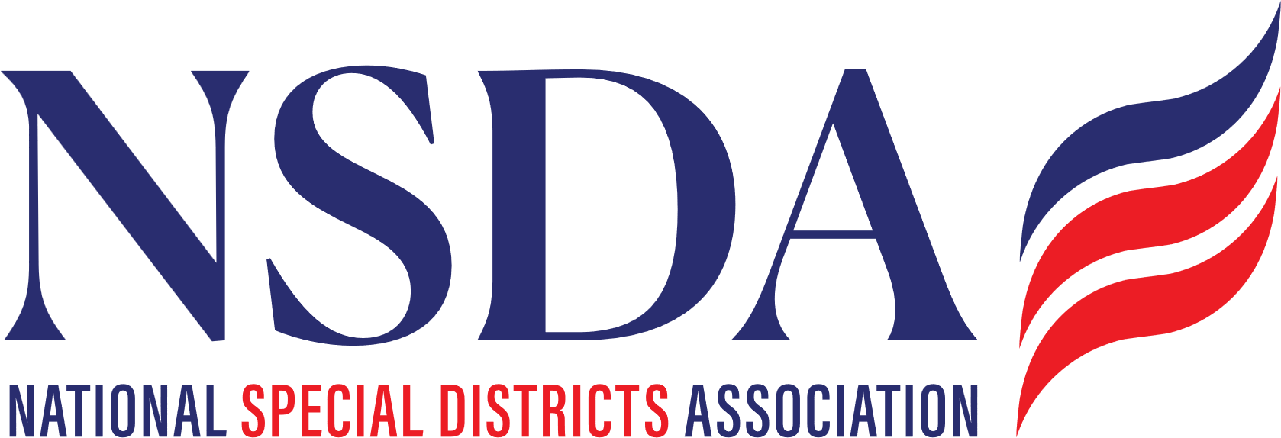 your logo here

[Date]

The Honorable __________
U.S. Senate
_______ Senate Building
Washington, D.C. 20510

RE: COSPONSOR the Special District Fairness and Accessibility Act of 2026 S. 2014

Dear Senator ________:

On behalf of _________, we respectfully request that you cosponsor the Special District Fairness and Accessibility Act of 2026 (S. 2014). This important bipartisan bill would establish a formal clarification of “special district” as a unit of local government in federal law.

S. 2014 is Sponsored by Senator Cornyn (R-TX) and Senator Merkley (D-OR) currently has 28 Cosponsors, its House Companion passed in the House Committee on Oversight and Government Reform, and most importantly, The Congressional Budget Office released their Cost Estimate. This important step in the process clarifies there is NO Direct Spending impact nor an impact on the Federal Deficit.

[Brief description of your district.]

Across our State, there are special districts championing local solutions and providing essential services and infrastructure such as fire protection, flood mitigation, and utilities - water, gas and electricity, highlighting the importance of effective and efficient local governance in your local communities.

We urge you to Cosponsor S. 2014.

Respectfully,

[Name]
[Title]

cc:
Senator John Cornyn
Senator Jeff Merkley
National Special Districts Association
Manatt, Phelps, Phillips

