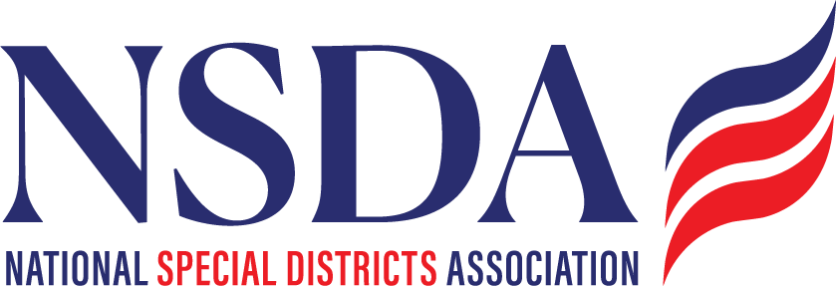
NSDA Federal Advocacy Committee Summary
6.25.26 1:00 pm MNT time

Welcome and Updates: Ann Terry
There is not a quorum so we will have to approve the meeting summary next month. NSDA will send out the power point so everyone can read more detail to keep today more focused on our priorities.

Federal Advocacy Update: Manatt Phelps and Phillips, LLC & Chantal Unfug
Priority Issues:
- SDFAA of 2026:
    - Focus is getting this to the floor during a lot of chaos
    - Target additional cosponsors: FLA, SC, CO: Mannat will work with each priority state to set up calls
    - NSDA will work with Gridbase to create heatmaps of member states.
    - Outreach to county organizations in member states
    - August recess push

  - OMB: Federal Grants/Funding Proposal
    - Big 7 drafted a letter requesting an extension
    - ASAE requesting feedback from the Association perspective
    - Munibond impacts by Moody’s downgrades
    - NSDA and Manat will meet after July 1st to decide final next steps.

Issues to Watch:
- Protect Charities Act: To do – decide if NSDA should comment
- Fire Apparatus Costs: NSDA will not be a lead on this – we will communicate it out, and support the Fire Associations.
- Fire Smart Act: Introduced – NSDA formally endorsed.
- FEMA Report Implementation: Comments have been submitted, now this is up to Congress – not expected until the Fall.
- Appropriations status update – not on track at this time. May be delays.
    - Farm Bill – Success for NSDA – includes extending Good Neighbor Authority to special districts.
    - Surface Transportation
    - Water Infrastructure
- Planning for 2027:
  - Confirm Dates – Will confer
  - Fly In Summit – NSDA to set up a meeting to discuss this.
- Committee feedback: Are there other issues to be aware of?

