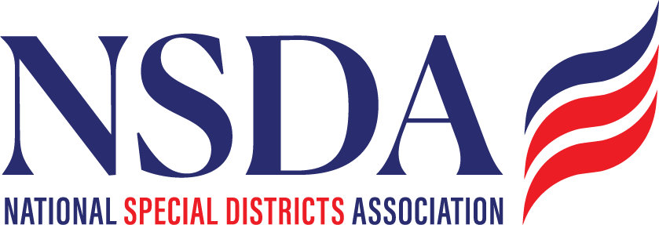

NSDC Federal Advocacy Committee

Agenda

9.25.2025

1:00 pm MNT time

[*https://us06web.zoom.us/j/85240694788?pwd=cFaB1TfCFa370f9hHB8T7easZI2uc1.1*](https://us06web.zoom.us/j/85240694788?pwd=cFaB1TfCFa370f9hHB8T7easZI2uc1.1)

*Meeting ID: 852 4069 4788*

*Passcode: 818259*

*One tap mobile*

*+17193594580,,85240694788#,,,,*818259# US*

*+13462487799,,85240694788#,,,,*818259# US (Houston)*

Welcome and Updates: Ann Terry

Federal Advocacy Update: Paragon Government Affairs

General Overview

1. HR2766 S.2014 – Sept - October strategy & targets
2. FY 2026 Appropriations / Continuing Resolution (CR) Update
3. Senate Hearing on Fire Apparatus Crisis
4. FEMA Reform Efforts
5. U.S. Wildland Fire Service
6. CMS Launch of Rural Health Transformation Program
7. October kick off work on 2026 agenda

* September: Committee provides feedback to create the 2026 version 1 draft for review in October.
* October: Draft review for approval of 2026 agenda by fed advocacy committee
* Annual Meeting - BOD to adopt the 2026 agenda

1. NSDA 5 Year Policy Agenda process discussion

Members’ new items questions or discussion

Next meeting date: October , 2025

**Federal Advocacy Program**

**2025**

**Objectives**

* **Advocate** on Federal Policy and Funding
  + - Influence federal legislative and regulatory actions as the voice for all special districts
    - Promote special district access to federal funding opportunities
    - **Access Funding**
    - Ensure awareness and readiness to compete for funding opportunities
    - Track, communicate, and support federal funding opportunities
* **Communicate** the Value of Special Districts
  + - Increase awareness and understanding of special districts and NSDA among federal policymakers and the greater public
    - Strengthen relationships with partner advocacy organizations
* **Educate** NSDA Members to be Effective
  + Track and inform federal legislative and regulatory matters of interest to all special districts
    - Ensure awareness of federal funding opportunities and equip members to effectively compete

**Priorities for 2025/2026 (119th Congress)**

**National Definition of Special Districts/Special District Fairness and Accessibility Act**

NSDA will work with key lawmakers to advance legislation to establish a first-ever, formal definition of “special district” in federal law. This would also require the White House Office of Management and Budget to issue guidance to federal agencies requiring special districts to be recognized as local governments for the purpose of federal financial assistance determinations.

**Public Finance**

NSDA supports reinstating or expanding public financing tools that help special districts secure essential project funding. This includes reauthorizing Build America Bonds, expanding private activity bonds, restoring advance refunding bonds, and protecting the tax-exempt status of municipal bonds; it also includes active participation in the Public Finance Network on issues such as limiting costly mandates associated with the Federal Debt Transparency Act.

**U.S. Census Bureau**

After enacting the Act, NSDA will work with Congress to direct sufficient resources to the U.S. Census Bureau to ensure that special districts are accurately counted in local government data sets, which are often critical to access federal funding opportunities.

**Federal Funding Opportunities**

NSDA will work to ensure that special districts are eligible for relevant discretionary and formula-based grant opportunities. Additionally, NSDA will advocate for dedicated technical assistance funding to help special districts navigate complex application processes and deliver projects more efficiently.

**Congressional Caucus on Special Districts**

NSDA will advocate for creating a Congressional Caucus on Special Districts. The caucus would serve as a dedicated platform to educate lawmakers and federal agencies about the unique challenges and essential functions of special districts and the communities they serve across the nation.

**Additional Issues to Monitor and Report**

**Administrative Functions:**

NSDA will continue to monitor and report on policies, rules, and regulations that directly impact the administrative management of special districts. In the near term, NSDA will watch Occupational Safety and Health Agency rulemaking and the Americans with Disabilities Act (ADA) updates.

**Cybersecurity**

NSDA supports federal programs and policies designed to bolster cybersecurity resilience through support and not through unfunded mandates. This includes advocating for initiatives that enhance threat detection, prevention, and response capabilities; promote best practices for data protection and privacy; and facilitate access to federal resources and training programs.

**Infrastructure**

NSDA supports the reauthorization of the *Infrastructure Investment and Jobs Act* and equitable inclusion of special districts as eligible entities to ensure that essential funding continues for a broad spectrum of critical infrastructure projects. A robust reauthorization would enable ongoing improvements to water and wastewater systems, strengthen transportation networks, expand broadband access, and enhance energy resilience.

NSDA will broadly support and promote programs aimed at strengthening water infrastructure, conservation efforts, groundwater recharge, recycling, and storage solutions, and specifically water infrastructure for firefighting. Additionally, NSDA will advocate for sound policies and strategic investments to address challenges facing drought-impacted communities, major river basins, and vital watersheds.

**Permitting Reform**

NSDA will support permitting reforms that streamline regulatory processes, reduce project delays, and lower costs associated with infrastructure development and maintenance, while maintaining a balanced approach that respects environmental protections.

**Disaster Resilience, Readiness, Response, and Recovery**

NSDA supports strengthening the resilience of special districts and the communities they serve. This includes advocating for federal programs and initiatives that would improve disaster preparedness and response, support local emergency management needs, and provide resources for infrastructure hardening, risk assessment, and recovery efforts.

NSDA supports policies and partnerships with stakeholders to advance shared goals for all disaster-impacted and disaster-prone special districts. NSDA also endorses policies that provide federal land management agencies with enhanced tools to facilitate effective forest management, forest restoration, and post-fire and water quality mitigation efforts.

**Farm Bill**

NSDA supports the timely reauthorization of the Farm Bill to sustain essential programs that strengthen rural development, enhance water infrastructure, promote conservation efforts, and improve disaster resilience.