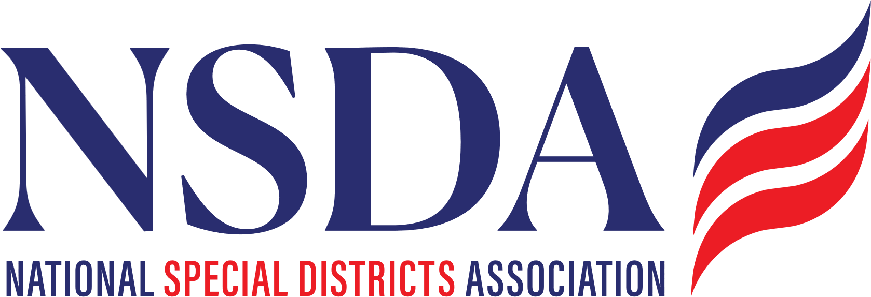 your logo here

[Date]

The Honorable __________
U.S. House of Representatives
_______ House Office Building
Washington, D.C. 20515

RE: Cosponsor Request – Special District Fairness and Accessibility Act of 2026 H.R.2766

Dear Representative ________:

On behalf of _________, we respectfully request that you cosponsor the Special District Fairness and Accessibility Act of 2026 (H.R. 2766). This important bipartisan bill would establish a formal clarification of “special district” as a unit of local government in federal law.

H.R 2755 is Sponsored by Representatives Pat Fallon (R-TX) and Brittany Pettersen (D-CO), currently has 28 Co-Sponsors, passed in the House Committee on Oversight and Government Reform, and most importantly, The Congressional Budget Office released their Cost Estimate. This important step in the process clarifies there is NO Direct Spending impact nor an impact on the Federal Deficit.

[Brief description of your district.]

Across our State, there are special districts championing local solutions and providing essential services and infrastructure such as fire protection, flood mitigation, and utilities - water, gas and electricity, highlighting the importance of effective and efficient local governance in your local communities.

Again, we urge you to cosponsor this important legislation and we ask that you work with your House colleagues to prioritize its passage.

Respectfully,

[Name]
[Title]

cc: Representative Pat Fallon
Representative Brittany Pettersen

